**6. After installation of docker run following commands to setup first project:**

Clone the project from github in order to run first project:

git clone <https://github.com/docker/getting-started.git>

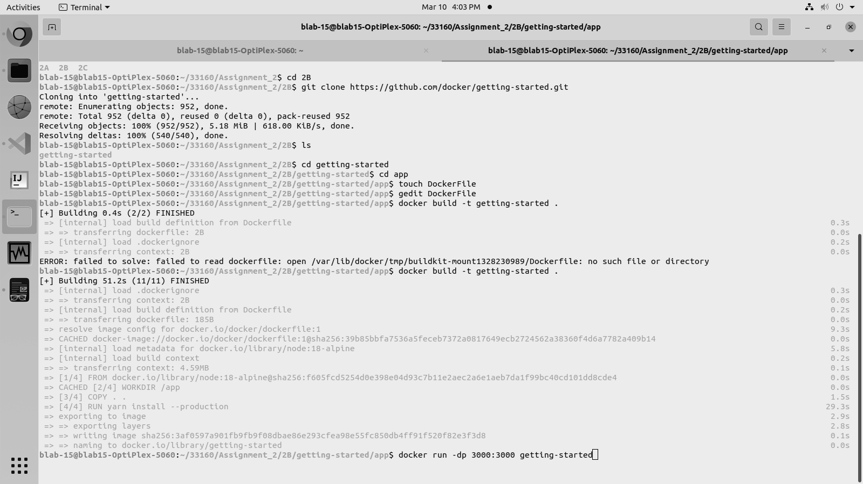

**7. Head to the app directory in getting-started folder and create a file named Dockerfile and add the following content in it:**

FROM node:18-alpine

WORKDIR /app

COPY . .

RUN yarn install --production

CMD ["node", "src/index.js"]

EXPOSE 3000



**8. Build the project using 1st command and then use the 2nd command to launch the project:**

1. docker build -t getting-started .
2. docker run -dp 3000:3000 getting-started



**9. To know the status of the project run following command:**

docker ps

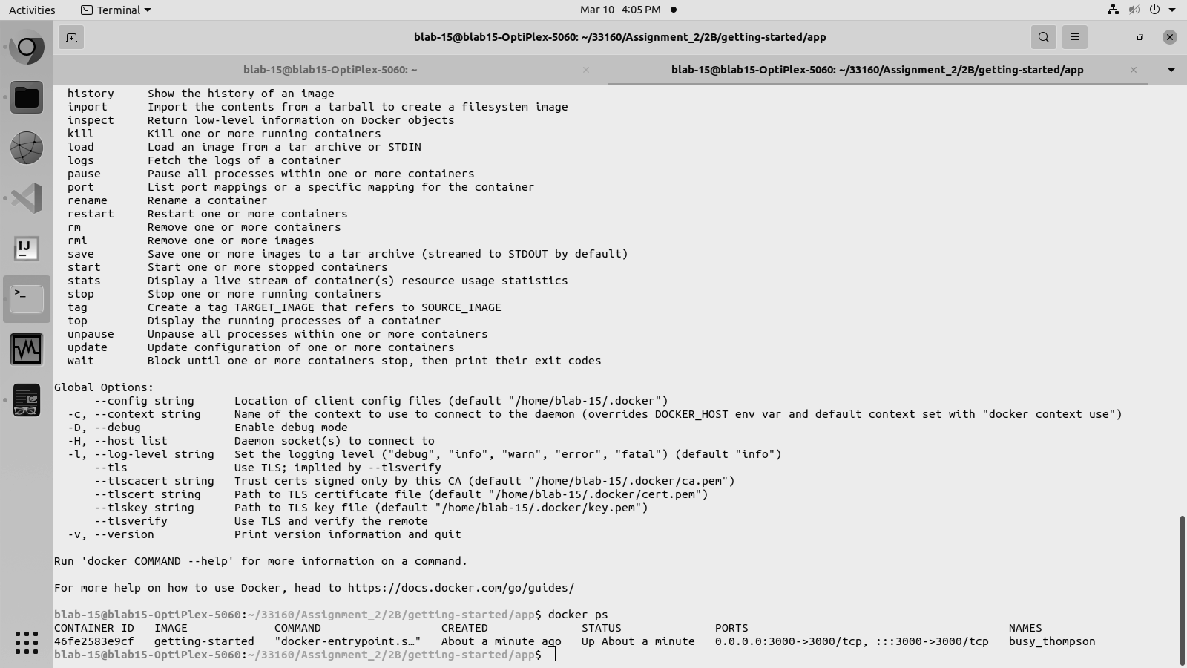

**10. The launched project will look like this:**

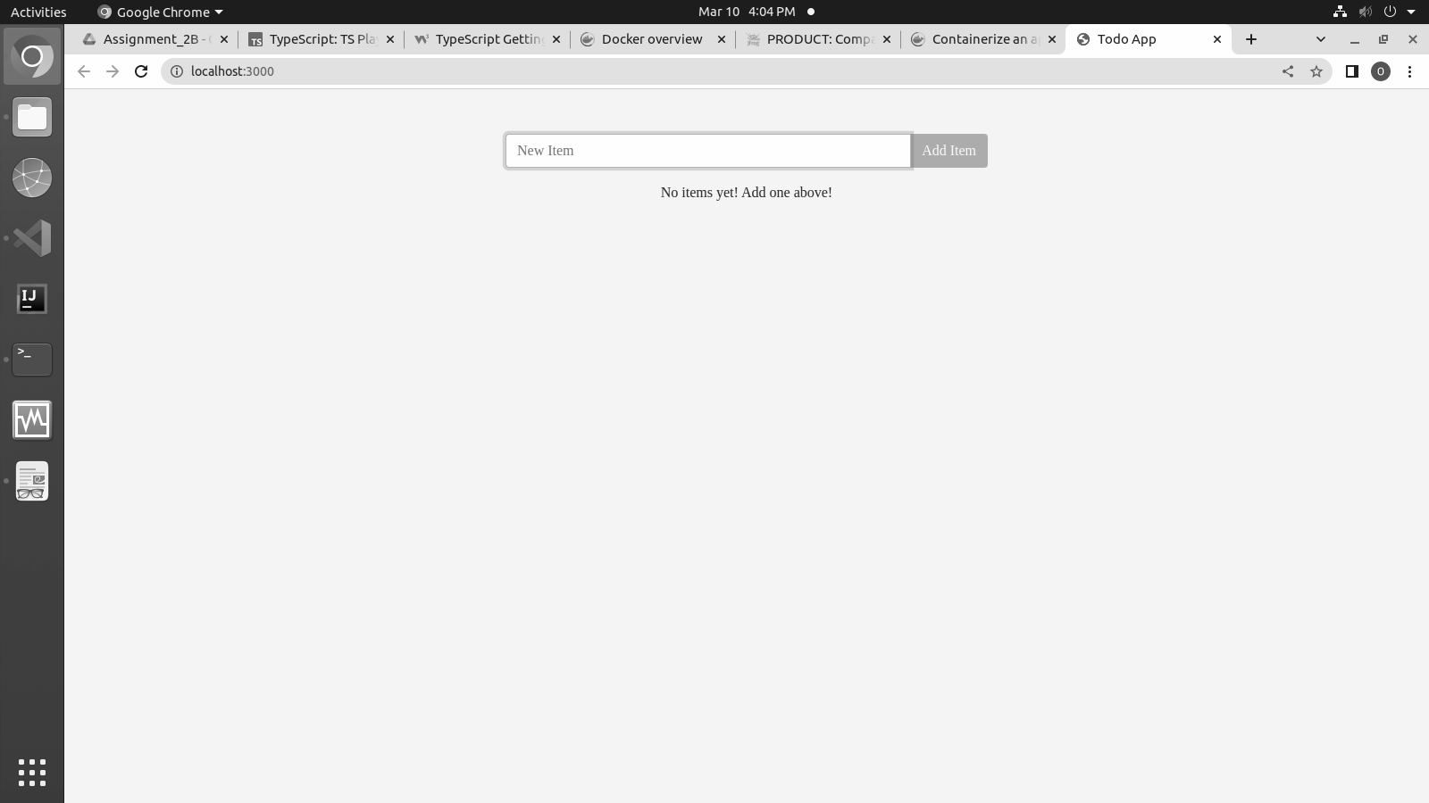

**11. After adding data it will look like this:**

